Basecamp Challenge Week: BACK ON TRACK !!!

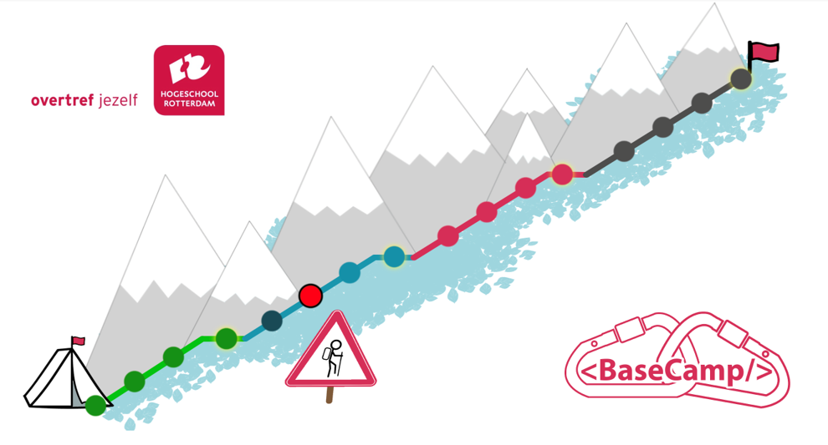

Introduction

This week is designed as a flexible week. If everything is going well, you will do a challenge assignment. If you experience difficulties and/or you are behind, you can use this week to get back on track.

This document describes the way to get back on track.

Back on track

The previous week you have talked with your basecamp teachers about your results with basecamp.

Maybe you experience difficulties, for example:

* you are behind schedule
* you have problems with planning
* you don't understand everything of python (learned so far)
* it is difficult to make a program on your own
* difficulty with finding errors in your programs
* difficulties with English, math, Dutch, concentration, motivation, ....

Personal Plan

At the start of the challenge week, you make a personal plan. Hand it in on Teams.

* **Why am I behind (i.e. difficult, illness, motivation, combination of…, etc.)?**

*I am behind because I couldn’t finish the problem 1 of week 7.*

* **What is already going well?**

*I understand the topics to date, just have to practice more.*

* **What haven’t I finished yet (theoretical base, exercises, problems, assignments, dossier etc.)?**

*Problems, assignments and some dossier assignments.*

* **What parts do I find difficult?**

*Working with codegrade, understanding the logic of coding.*

Then you make a plan to work on this week

* **What do I want to learn this week?**

*I just want to finish the problems and the assignment*

* **Where do I need help?**

*I need some guidance with the logic and how I can simplify my code, because I write very long code and sometimes I’m just running in circles.*

* **What problems/assignments can I work on?**

*Week 07*

* **Which topics need more research/knowledge?**

*Inner loops, lambda functions and dictionary, list, tuples.*

* **Planning for this week and how you will stick to it**

*I’ll just work on the problems and try to finish the assignment before Monday.*

During the week you work according to your plan. Try to work together with other ‘Back on Trackers’; you can support each other. During the week there will be peer coaches and teachers available for questions.

At the end of the week, you hand in a short summary of what you have completed @teacher: create assignment in teams:

* **What did I complete?**

I finished the assignment before Monday,

* **Did I manage to stick to my plan?**

Yes

* + If not, why not?
* **What are you proud of?**

I’m proud that I finished the assignment before the problems, which technically means I’m not behind anymore.

* **What can you improve on?**

Just spend more time on coding, I was not using my time properly.